CREATING A TABLE NAMED TITANICS AND LOADING THE GIVEN DATA

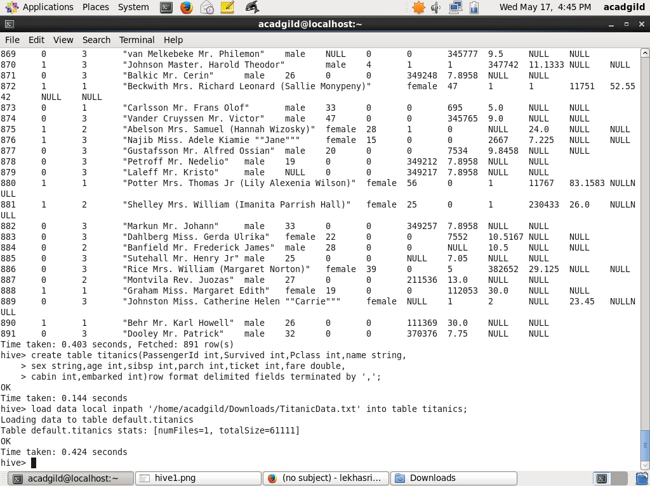

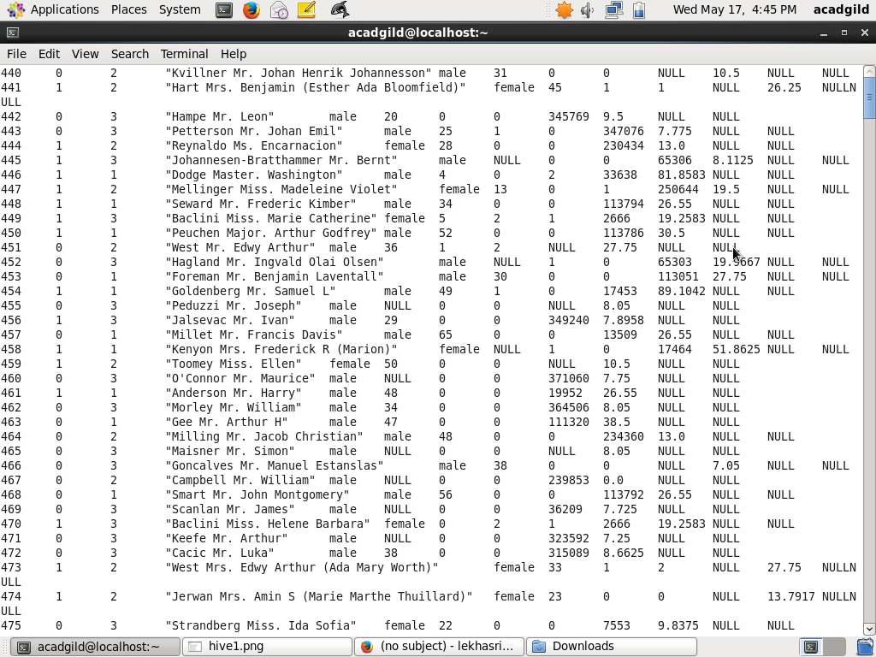

hive query to find the average age of male and female persons died in the titanic tragedy

select avg(age) from titanics where survived=1 group by sex;

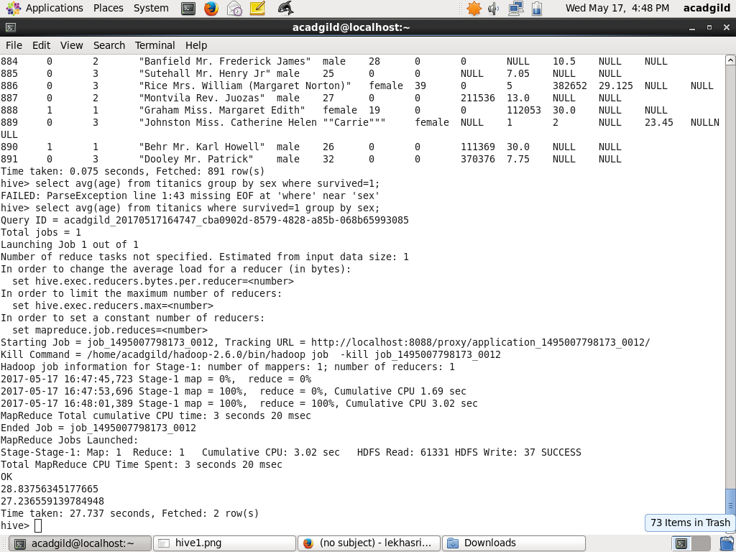

hive query to find the number of people died and survived in each class

select count(survived) from titanics where survived=1 group by pclass union all select count(survived)          
from titanics where survived=0 group by pclass;

